

**Weather and Appointment Attendance Demonstration**



|  |  |
| --- | --- |
| Date: | **24th November 2017** |
| IBM Analytics Platform Specialist | **Jon Simmons** |

***Any questions on this document and the demonstrations please direct them to jon.simmons@uk.ibm.com.***

Synopsis 3

Architecture and Design 4

Data Structures 5

Data Items 6

Watson Analytics Data Set 8

Setting up the data into Db2 Warehouse on Cloud 10

Watson Analytics Demo on the Data 16

DSX Demo on the data 27

Jupyter Notebook Demo on the Attendance Data 27

Machine Learning – SPSS Modeler Demo on the Attendance Data 27

Example run of the Neural network 28

# Synopsis

The following short document outlines the details of a demonstration produced to show the integration of the Weather data from the Weather service with other cloud services including the use of the Data science Experience (DSX), Cloudant and Db2 Warehouse on Cloud (Formerly dashDB). The results can be displayed in either DSX or using Watson Analytics.

The demonstration is positioned in the use case of attendance of patients to health appointments and the effect of the weather on attendance percentages. Obviously this can be extended to a number of similar use cases where attendance is crucial and weather conditions can affect attendance in other industries.

Why is appointment attendance important and predicting the levels of attendance?

The answer is to ensure that optimum allocation of expensive resources (Doctors, Consultants, Nurses, Equipment, Beds, Space…). Too much resource will result in higher costs, lost opportunity costs and wasted resource that could have been deployed elsewhere. Too little resource will mean a poor experience and service for the attendee (patient) and long waiting time.

So the other main reason for this type of analysis is to improve the attendee (patient) experience, reducing waiting times, improving attendee satisfaction (so that they come again) and improving the reputation of the supplying authority

Data from the weather service has been obtained for a 2 year period covering a triangle of points and loaded into Db2 Warehouse on Cloud. The weather data is combined (joined) with the attendance data already loaded. DSX can be used to display some of the findings.

A data set of joined data will be loaded into Watson Analytics to allow further insights to be shown form a citizen analyst point of view.

# Architecture and Design

The following section describes the architecture and design of the demo. The diagram below outlines the architecture and design.

The demonstration is built on IBM Cloud services deployed in IBM Softlayer data centres.



The components or services used include: -

* Db2 Warehouse on Cloud (Formerly dashDB, relational and analytical store for the data engineer)
* The Weather Company Service (Application developer.) and superset of data from the Waether company.
* Data Science Experience (DSX – for the data scientist to create predictive and ML models on attendance.)
* Watson Analytics – (Visualisation and insight for the Citizen Analyst)

The demonstration is quite useful in showing a variety of the personas (Data engineer, Data scientist, and Citizen Analyst) with use of some services in the Watson Data Platform with other services.

# Data Structures

The data is structured data. This data and data structures form a star schema around a fact table of attendance events, with dimensional data. Historical data is held spanning back a 2 year period to show YoY analysis and trends, if required.

The main relational data tables: -

1. Venues or Locations (Of clinics, Hospitals) - Dimension
2. Attendee (Party) Details – Name, home address, preferences - Dimension
3. Session Details - Dimension
4. Time/Calendar – Dimension
5. Attendance records (Events)

This data will be joined with historical weather data from the Weather Company Data from the extended weather service to determine what types of weather were occurring at the time of the appointments at Attendees home address and at the Venue and what factors in analysis affect attendance.

The resulting rectangular joined data set will be used in Watson Analytics and DSX to find patterns in the data and insight. These correlations can then be used to create a predictive model in the future to predict the levels of attendance rates to determine resource allocation and staffing levels given the forecast in the future.

The high level data model is shown below:-



# Data Items

The following are definitions of the detailed data in each of the entities: -

**Venues**

VenueId

VenueNumber

VenueType

VenueName

VenueDescription

VenueAddress

VenuePostTown

VenuePostCode

VenueLong

VenueLat

VenueDistrict

VenueCounty

VenueRegion

VenueWSLat

VenueWSLong

**Attendee (Party)**

AttendeeId

Type

Forename

Surname

PostTown

PostCode

HomeLat

HomeLong

County

Region

HomeWSLat

HomeWSLong

**Session Details Summary**

SessionId

SessionDate

SessionStartTime

SessionEndTime

SessionVenueId

NumberofBeds

NumberofConsultants

NumberofNurses

NumberInvited

NumberAttended

NumberofDonations

TotalBloodCollected (Litres)

**Time Calendar Dimension – Day/Date Granularity**

TimeId

DayDate

CalMonth

CalQtr

CalYear

CalDayofMonth

WeekDayNumber

**Attendance Event**

AttendanceEventid

AttendeeId

SessionId

VenueId

AttendanceDate

AttendanceStartTime

AttendanceEndTime

EventCost

**Weather Data**

SiteID

WSLat

WSLong

DateHrGmt

DateHrLwt

SurfaceTemperatureCelsius

SurfaceDewpointTemperatureCelsius

SurfaceWetBulbTemperatureCelsius

RelativeHumidityPercent

SurfaceAirPressureKilopascals

CloudCoveragePercent

WindChillTemperatureCelsius

ApparentTemperatureCelsius

WindSpeedKph

WindDirectionDegrees

PrecipitationPreviousHourCentimeters

DownwardSolarRadiationWsqm

DiffuseHorizontalRadiationWsqm

DirectNormalIrradianceWsqm

MslPressureKilopascals

HeatIndexCelsius

SnowfallCentimeters

SurfaceWindGustsKph

# Watson Analytics Data Set

The data items above need to be consolidated into a data set for Watson Analytics. Watson analytics requires a flattened version of a star schema called an R-Cube (Relational cube). This means the data from the tables above is joined into one flat data set. The joined data items should be as follows with the Attendance event the driving table.

**Watson Analytics Data Set**

AttendanceEventid

Attendeeid used to join to Attendee table and obtain

AttendeeForename

AttendeeSurname

AttendeePostTown

AttendeePostCode

AttendeeHomeLat

AttendeeHomeLong

AttendeeCounty

AttendeeRegion

AttendeeWSLat

AttendeeWSLong

SessionId used to join to the SessionDetails table and obtain

SessionDate

SessionStartTime

SessionEndTime

NumberofBeds

NumberofConsultants

NumberofNurses

NumberInvited

NumberAttended

NumberofDonations

TotalBloodCollected (Litres)

VenueId used to join to the Venue table and obtain

VenueName

VenueDesc

VenueAddress

VenuePostTown

VenuePostCode

VenueLong

VenueLat

VenueCounty

VenueRegion

VenueWSLat

VenueWSLong

AttendanceDate

AttendanceStartTime

Used the start time to join to weather data find the nearest weather records for the attendance Start Time. We need two weather records, weather at home location and weather at venue. Use the VenueLong and VenueLat and the Attendancestarttime to find the most suitable weather record at the venue and also the HomeLat and HomeLong for the most suitable Home Weather record.

(There are three weather location readings -Maidstone, Penzance and Manchester)

HomeWeather

Home.SurfaceTemperatureCelsius

Home.SurfaceDewpointTemperatureCelsius

Home.SurfaceWetBulbTemperatureCelsius

Home.RelativeHumidityPercent

Home.SurfaceAirPressureKilopascals

Home.CloudCoveragePercent

Home.WindChillTemperatureCelsius

Home.ApparentTemperatureCelsius

Home.WindSpeedKph

Home.WindDirectionDegrees

Home.PrecipitationPreviousHourCentimeters

Home.HeatIndexCelsius

Home.SnowfallCentimeters

Home.SurfaceWindGustsKph

VenueWeather

Venue.SurfaceTemperatureCelsius

Venue.SurfaceDewpointTemperatureCelsius

Venue.SurfaceWetBulbTemperatureCelsius

Venue.RelativeHumidityPercent

Venue.SurfaceAirPressureKilopascals

Venue.CloudCoveragePercent

Venue.WindChillTemperatureCelsius

Venue.ApparentTemperatureCelsius

Venue.WindSpeedKph

Venue.WindDirectionDegrees

Venue.PrecipitationPreviousHourCentimeters

Venue.HeatIndexCelsius

Venue.SnowfallCentimeters

Venue.SurfaceWindGustsKph

AttendanceEndTime

EventCost

# Setting up the data into Db2 Warehouse on Cloud

The data is supplied in a number of CSV tables one for each table. Copy these into your home demo directory.

The following files will be present: -

ATTENDANCE_EVENT.csv,

ATTENDEE.csv,

SESSION_DETAILS.csv

TIME_DIMENSION.csv

VENUE.csv

WEATHER_DATA_Maidstone_2015.csv,WEATHER_DATA_Maidstone_2016.csv, WEATHER_DATA_Maidstone_2017.csv,WEATHER_DATA_Manchester_2015.csv, WEATHER_DATA_Manchester_2016.csv,WEATHER_DATA_Manchester_2017.csv,

WEATHER_DATA_Penzance_2015.csv,WEATHER_DATA_Penzance_2016.csv, WEATHER_DATA_Penzance_2017.csv

Create a Db2 Warehouse on Cloud Entry plan on your IBM Cloud account

Login and open the Db2 warehouse on Cloud console you should may see a screen as follows: -

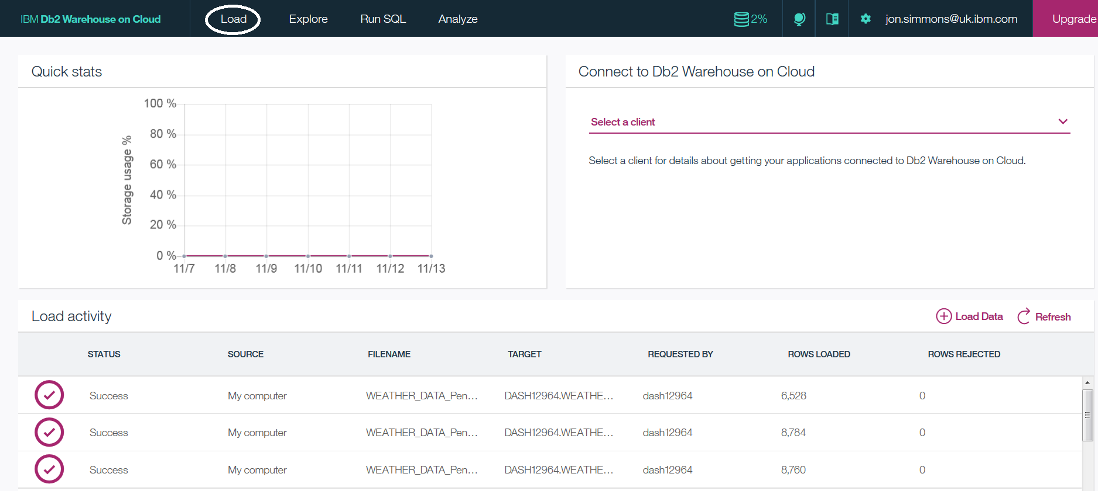

Load the csv data into a schema on you BLUDB database instance using the Db2 warehouse on Cloud load wizard functionality which is circled in the diagram above. When you press the load button you will get the following screen. This is a step by step wizard that chooses the source, target, defines some fields and then loads the data.

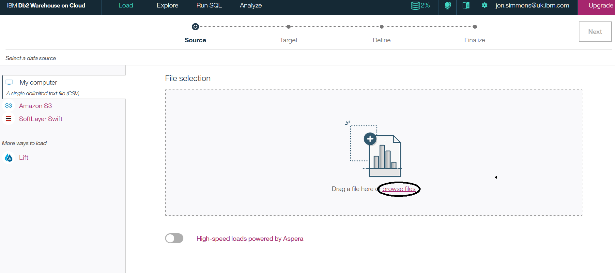

Browse files for your data directory. Each file has the first row for column headers (names). Select a file and hit the NEXT button top right. The target screen is displayed below: -

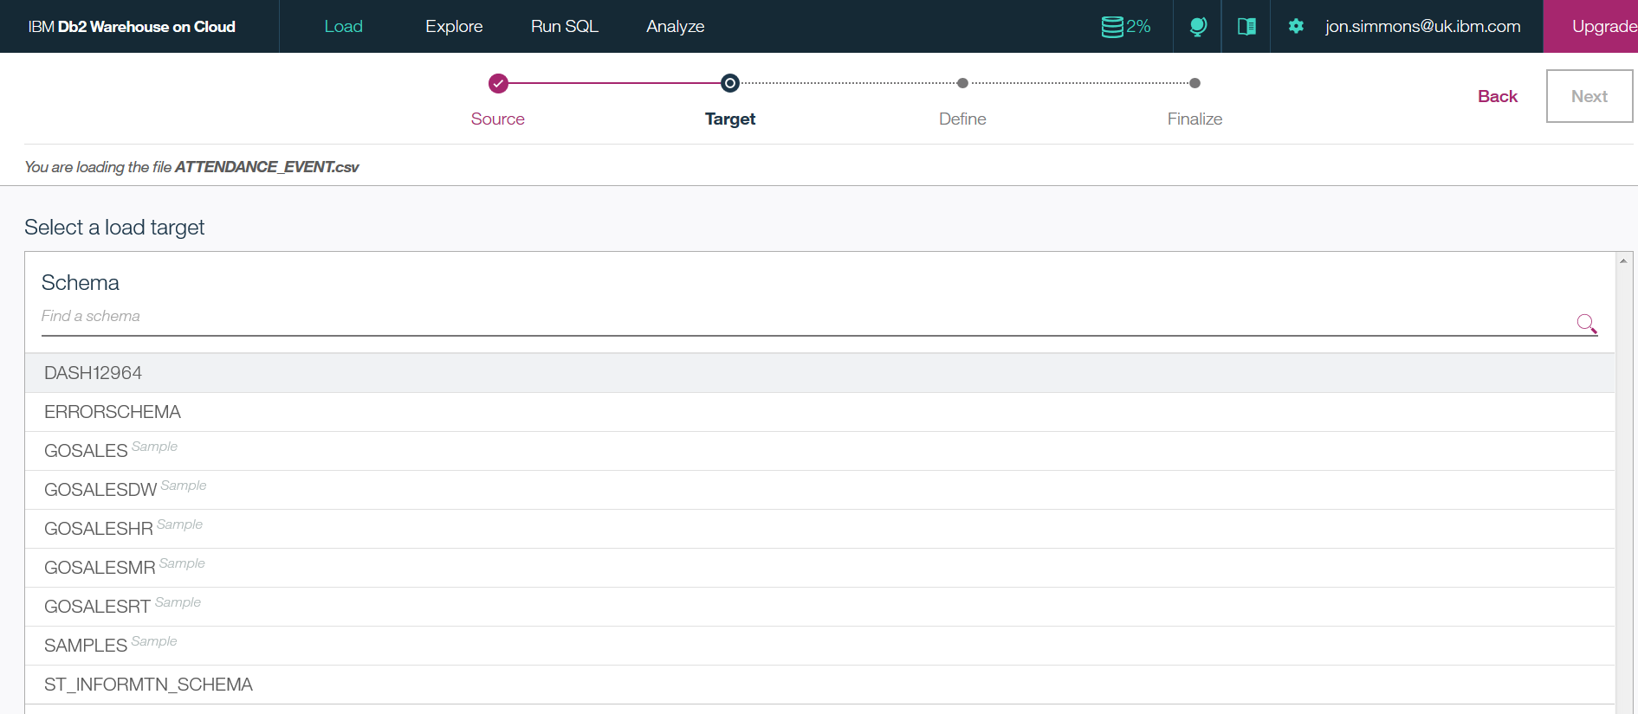

Select a schema to load the data into.

If loading the data for the first time select “New table” which is circled in the diagram below.

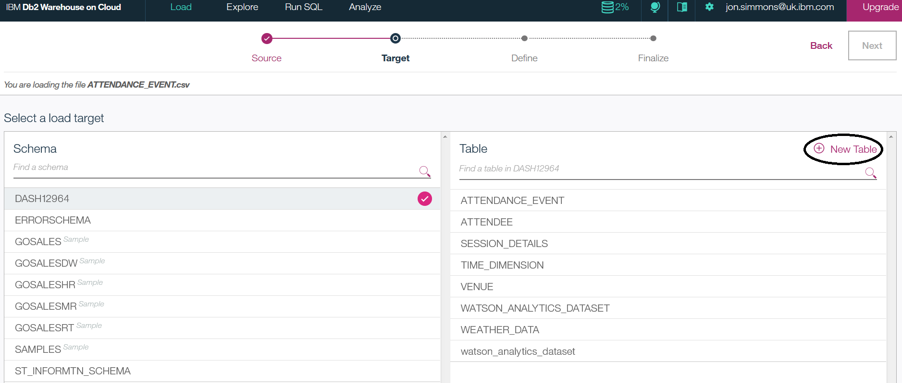

Type in the name of the table you wish to load to (Same as the csv file name without the “.csv”.). If this is not the first time loading select the relevant table and overwrite the existing data if any in the table

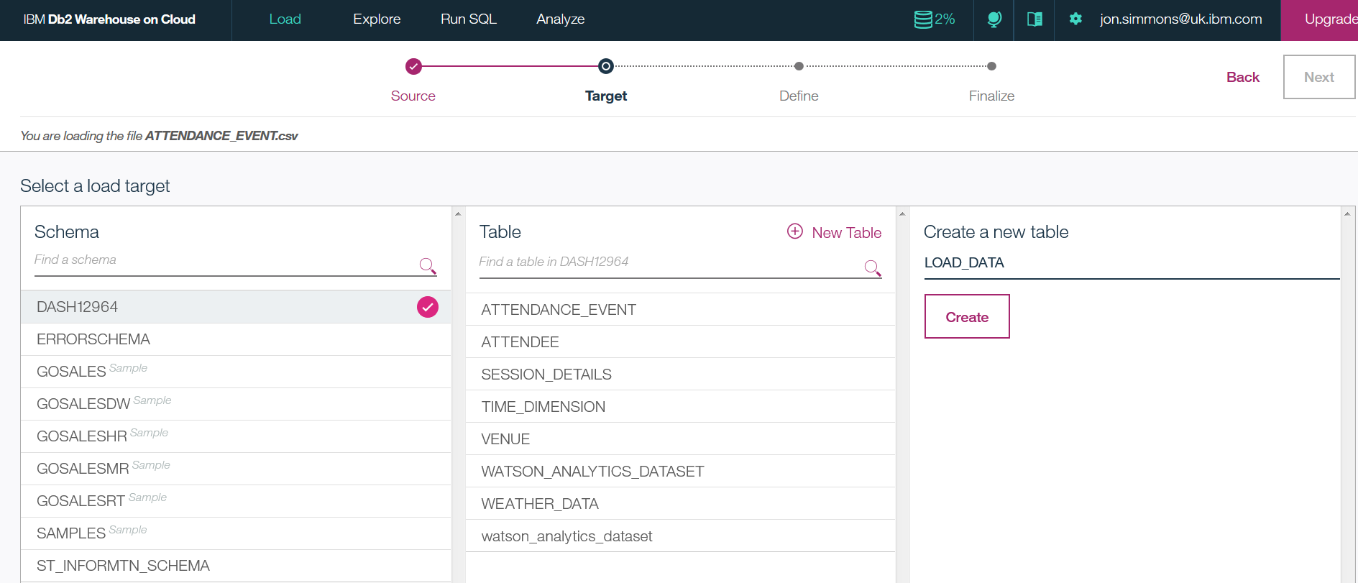

Press the create button to create the table and then the Next byutton in the top right.

The columns should be defined correctly and the file will load the data.

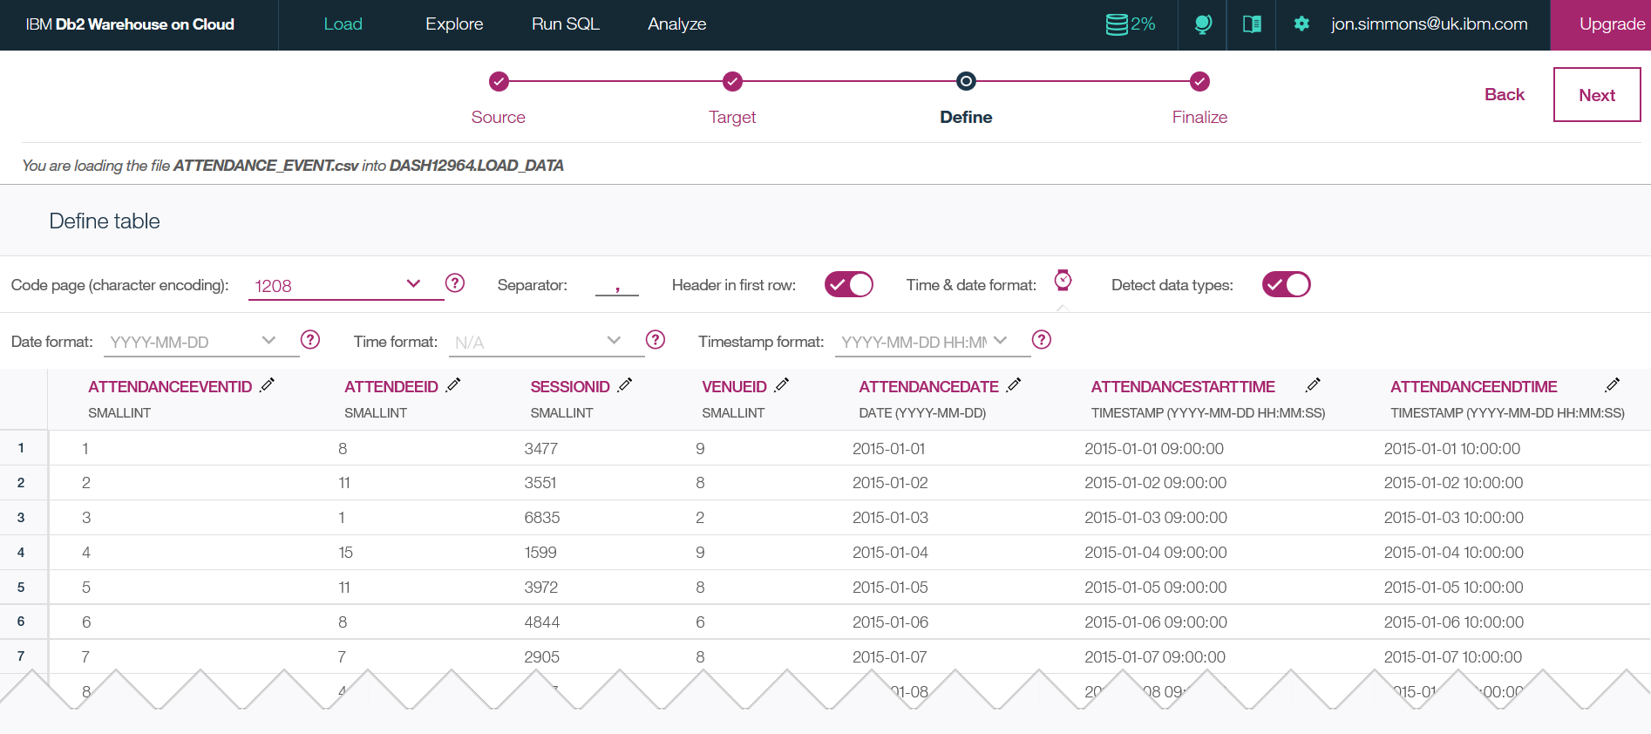

The only exception is the weather data files.

(NOTE when loading the Weather data files you need to define the Date format as “MM/DD/YYYY”, the Time format as “HH:MM:SS” and the Timestamp format as “MM/DD/YYYY HH:MM:SS”.)

Once columns are defined press the Next key in the top right of the screen to finalize the load. The following screen will be displayed.

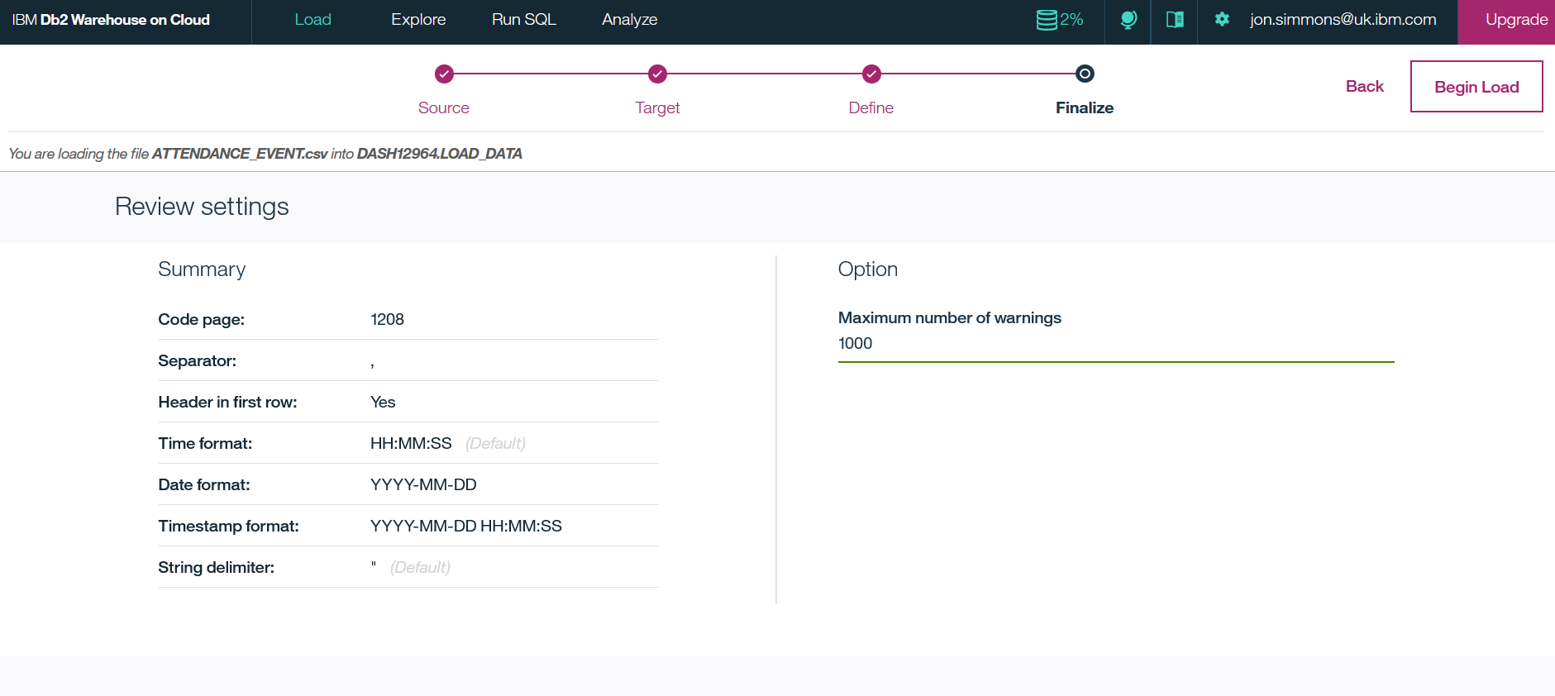

Press the begin load button in the top right and watch the file load the data.

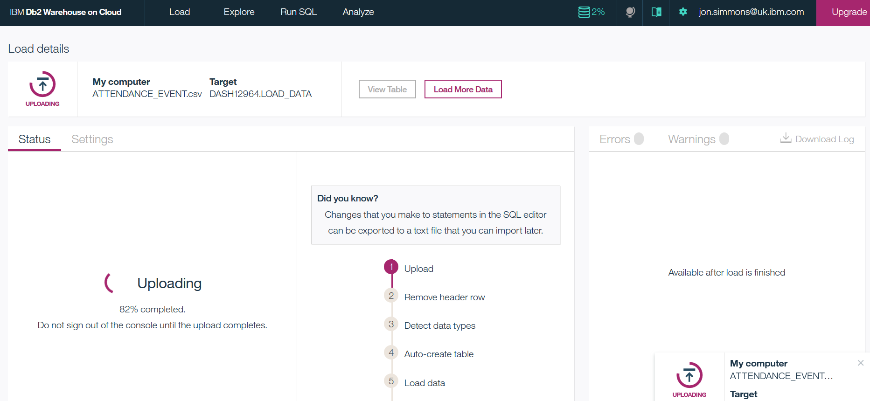

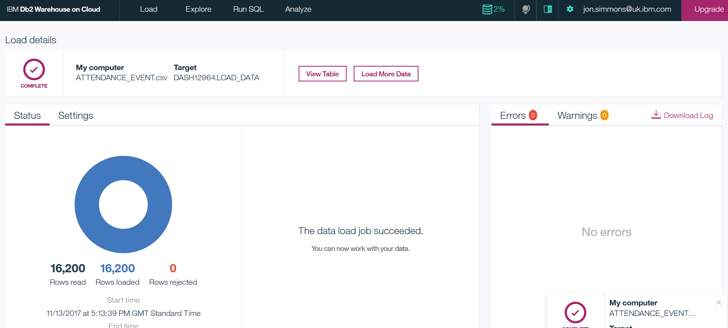

Make sure there are no errors, warnings or rejected rows.

Repeat this process for each CSV file. Remember to load the WEATHER_DATA files into one table called WEATHER_DATA

The above process and csv file data creates base table data.

There is one SQL file. This creates results of a rectangular data set into the table WATSON_ANALYTICS_DATASET for analysis with Watson Analytics front end. There is also a csv file with this data in instead of using the SQL.

You can run this SQL in the Db2 Warehouse on Cloud console. The following screen shots shows how: -

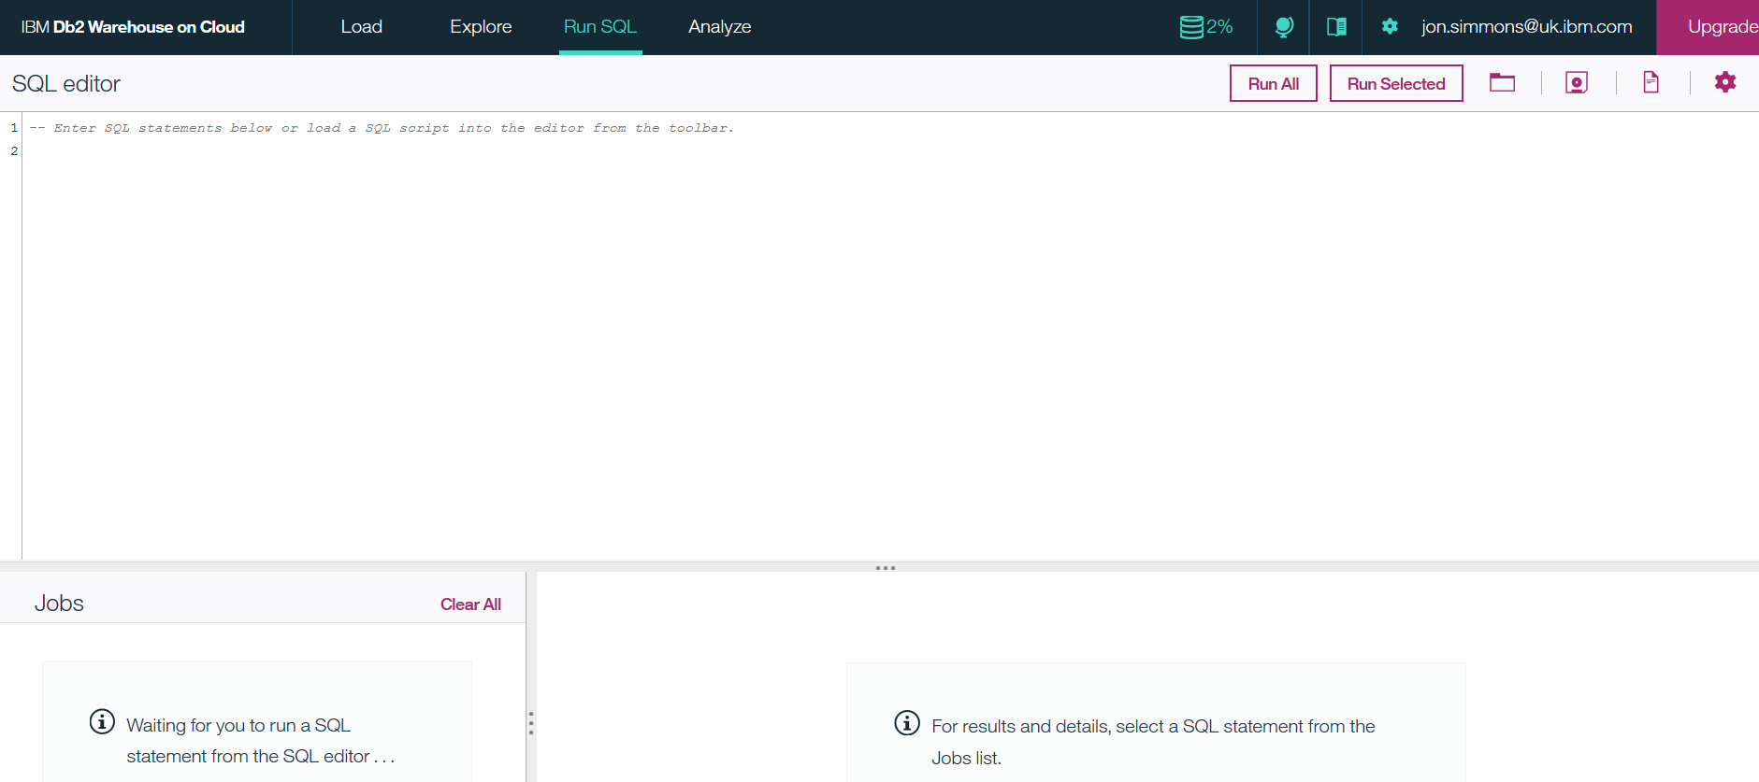

The screen above is the run SQL screen. Click on the folder icon towards the top right, to select the SQL file as in the window below.

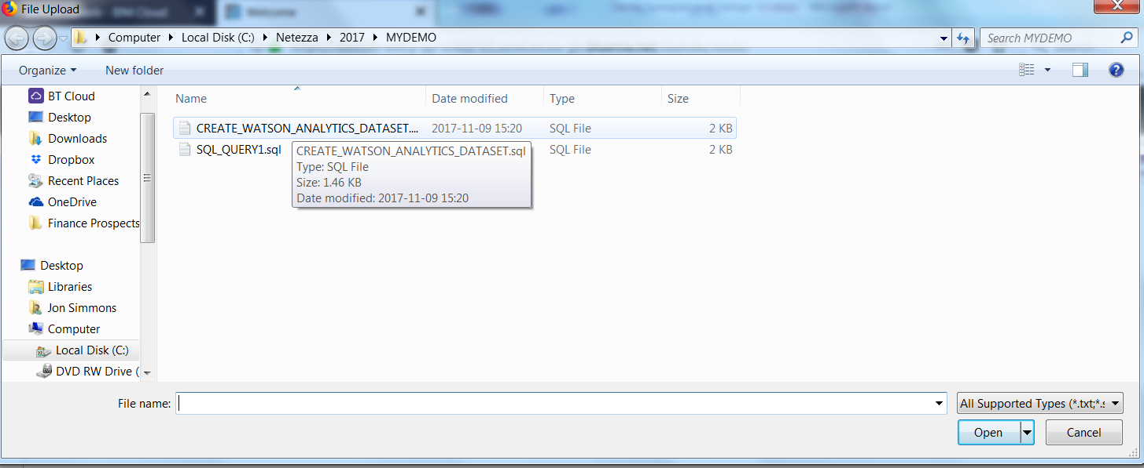

Click the “Run All” button and the table will be created and populated with the data from the base tables.

The data is now ready to be used in Watson Analytics and in DSX (Data Science Experience)

# Watson Analytics Demo on the Data

Login to Watson analytics. The Analytics Platform and Big data team has a login and shared account. If you are having difficulties asked Joe Plumb. Using the website

<https://watson.analytics.ibmcloud.com/home/data/?folder=b58ab26a-24ef-477a-b048-c517761b4f88>

The following screen will be displayed: -

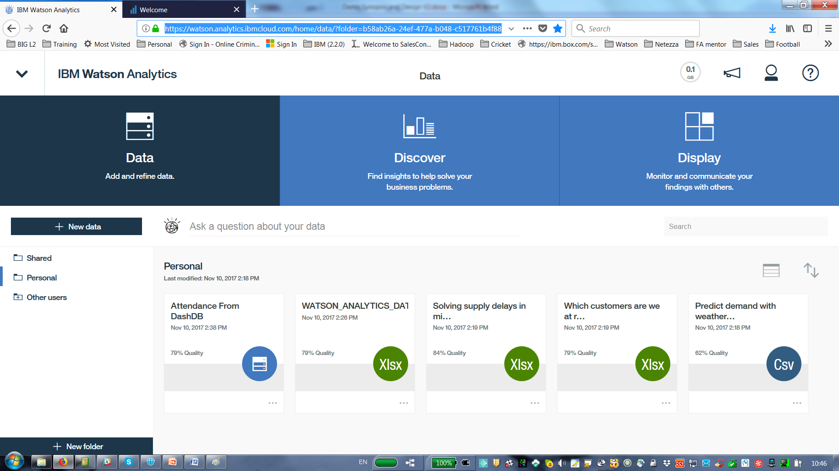

There are three stages to creating Watson Analytics applications.

1. Connect and load the data (Watson Analytics uses Mongo DB under the covers)
2. Create some discoveries on your data. Watson Analytics will suggest questions or areas of interest. You can type natural language questions
3. Create a display or dashboard

**Data**

The data has been connected in two ways to Watson Analytics.

1. An XLSX file of the resulting table created in Db2 warehouse on Cloud
2. A connection to Db2 Warehouseon Cloud allowing us to select the correct schema and table.

To add an XLSX file rconnection, press the “+ new data” near the top left. The following screen is displayed.

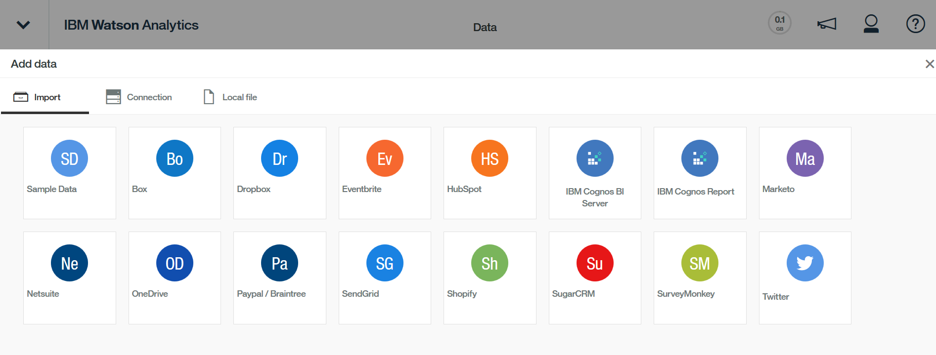

Choose the “Local File” option and hit the “Browse” button to navigate to where the WATSON_ANALYTIC_DATASET.xlsx file is located. The file will be displayed in the window, hit the “Import” button in the bottom right of the screen.

To add a connection you need to select the account settings from the main screen when you login. This is done by selecting the person icon in the top right and selecting “Account settings”.

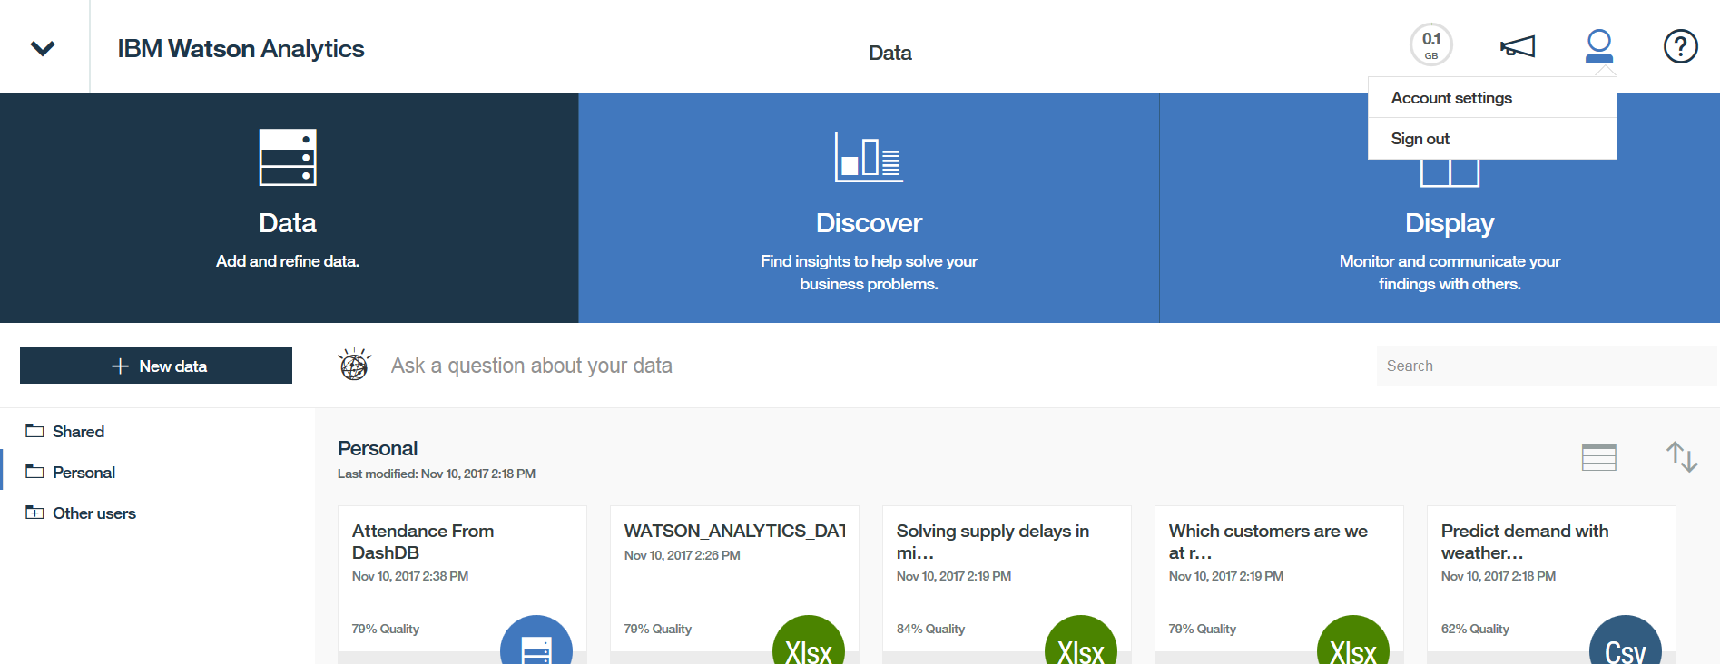

A screen similar to the following will be shown.

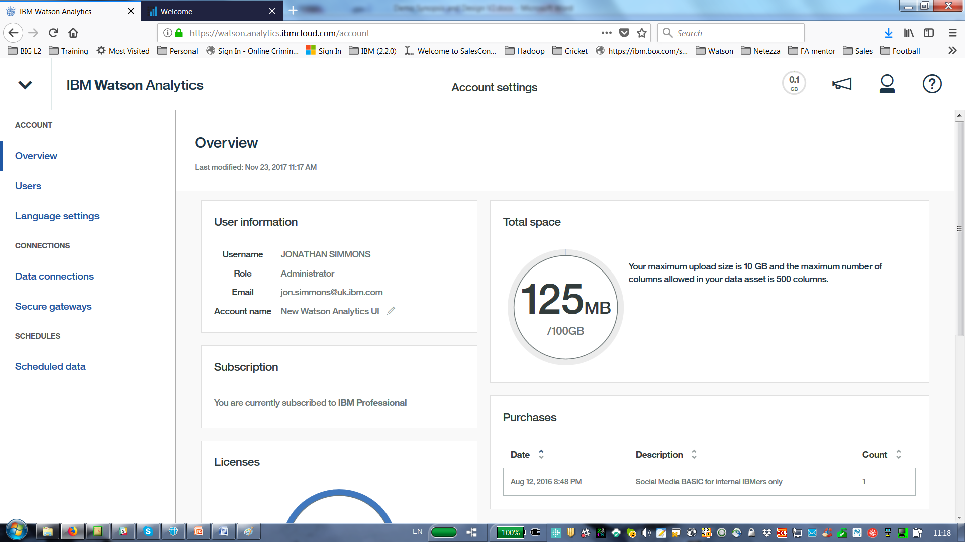

Select data connections on the left hand side, the following screen will be displayed.

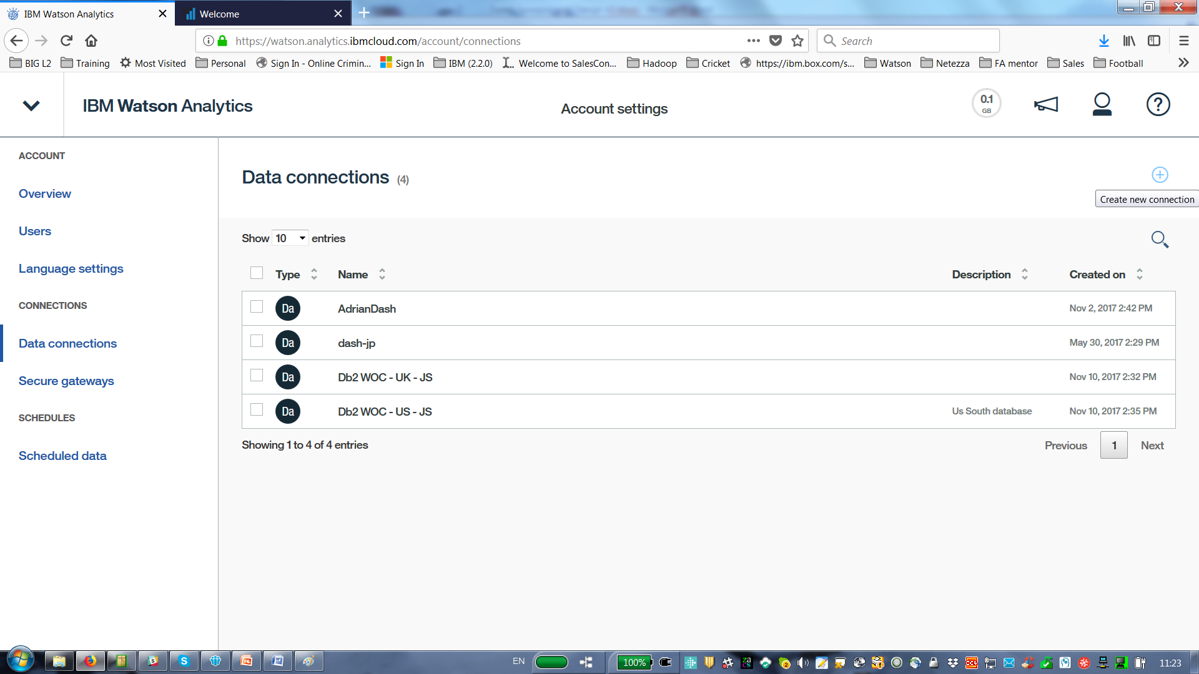

Press the + in the top right hand part of the screen as shown to Create new connection.

Select the IBM DashDB connection from the screen below.

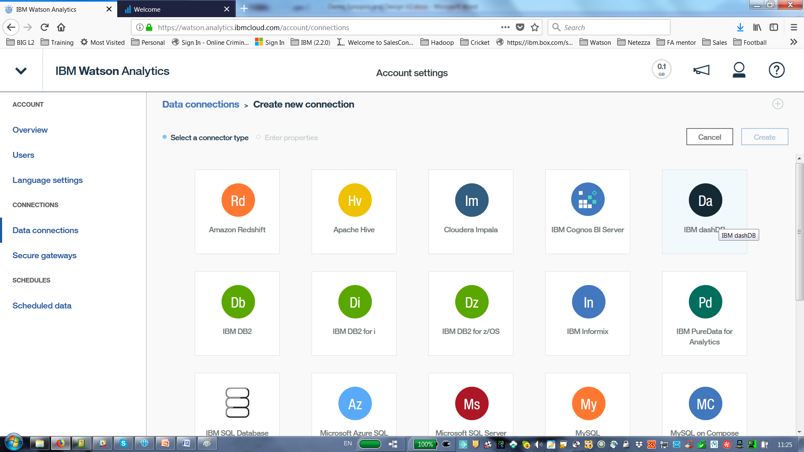

Now we see the following screen.

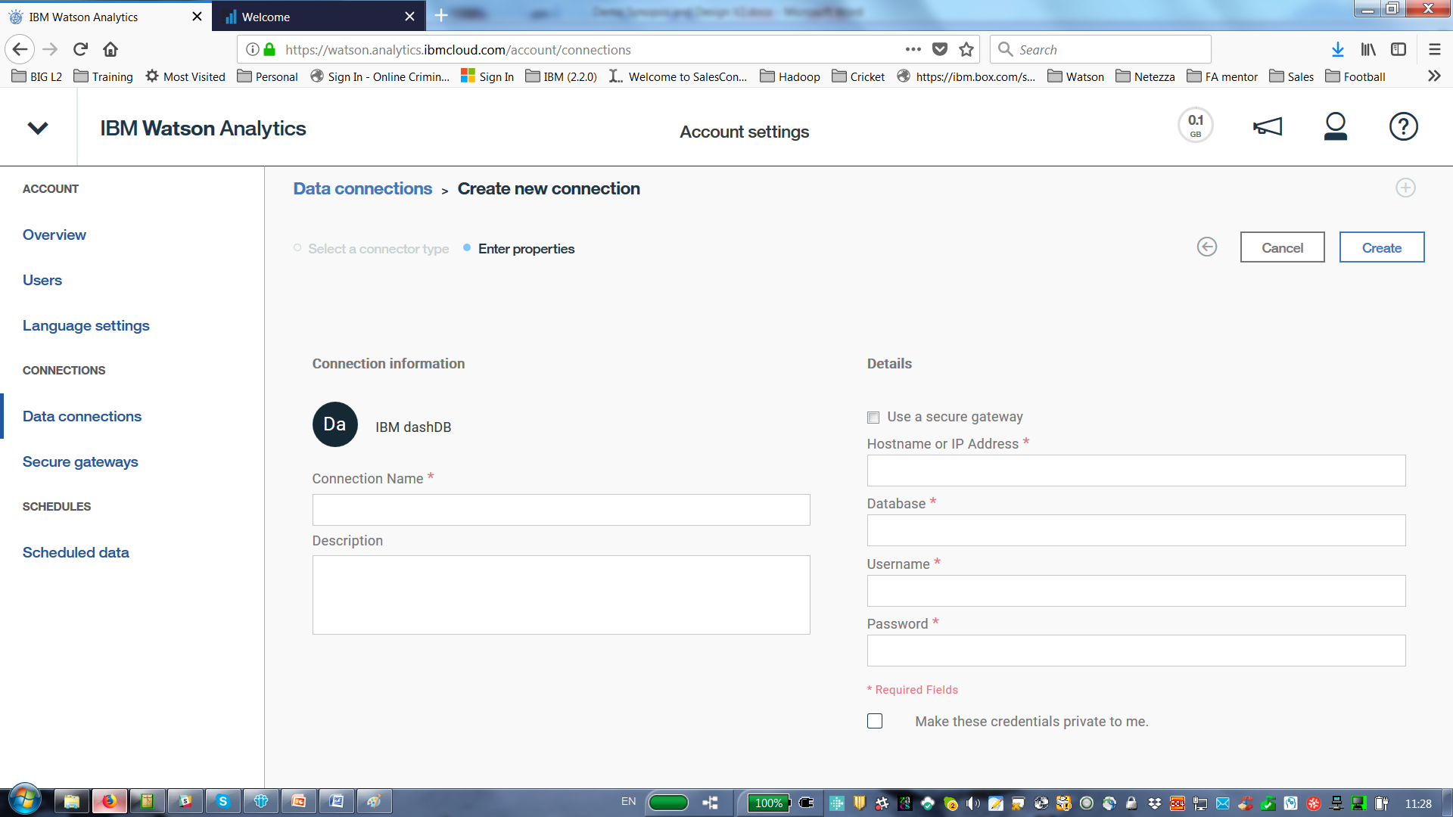

To fill in the properties you need to go to have the credentials of your Db2 Warehouse on Cloud database. Once you have filled in the properties press the “Create” Button, top right of the screen and the connection will be created if you have filled it in correctly.

**Db2 Warehouse on cloud Credentials**

To find the credentials of your Db2 Warehouse on Cloud database on IBM cloud login to your IBM Cloud services. A screen similar to the following will be shown: -

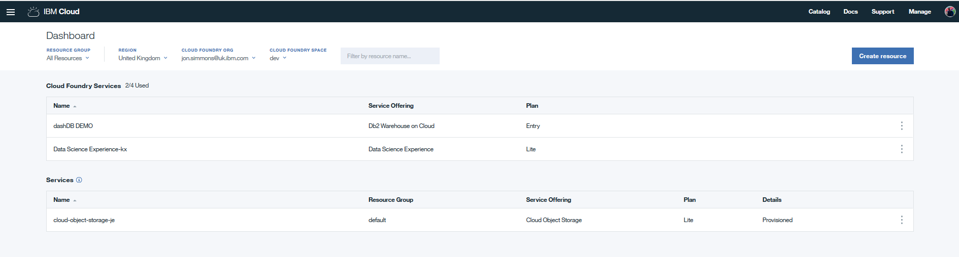

Select your Db2 warehouse on Cloud service and a screen as follows will be shown: -

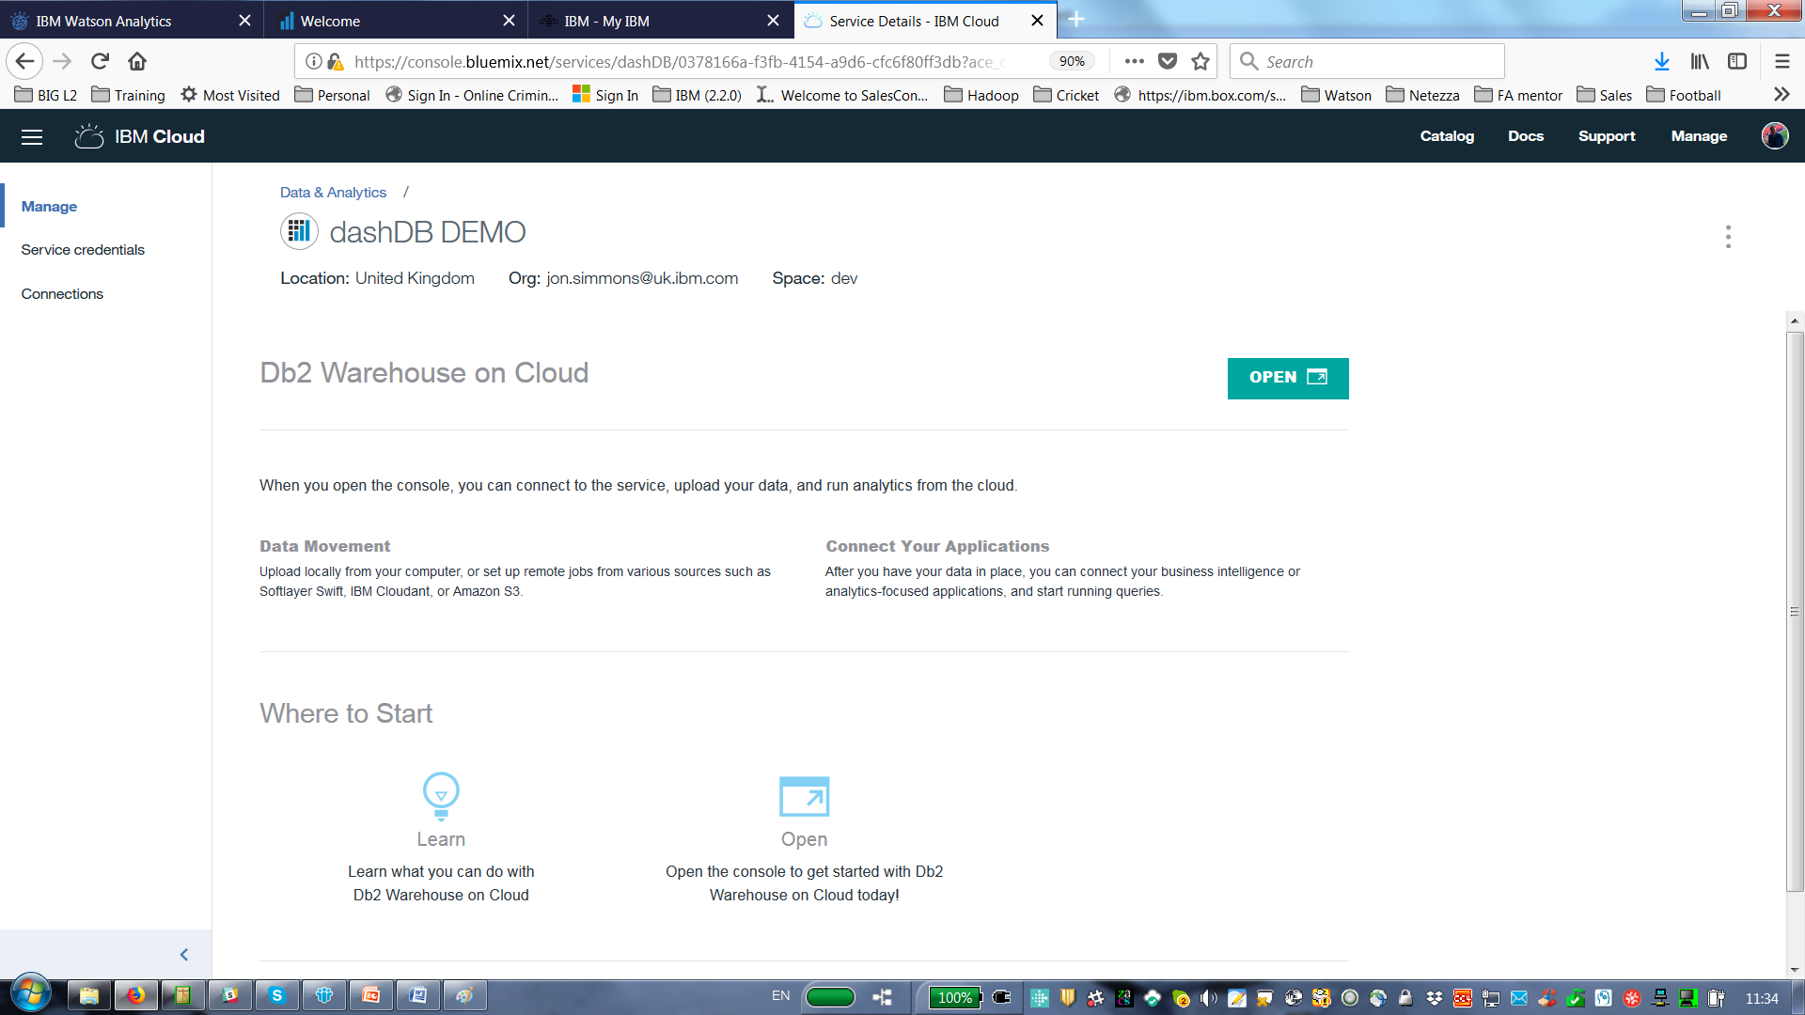

Select the service credentials on the left, a screen as follows will be shown: -

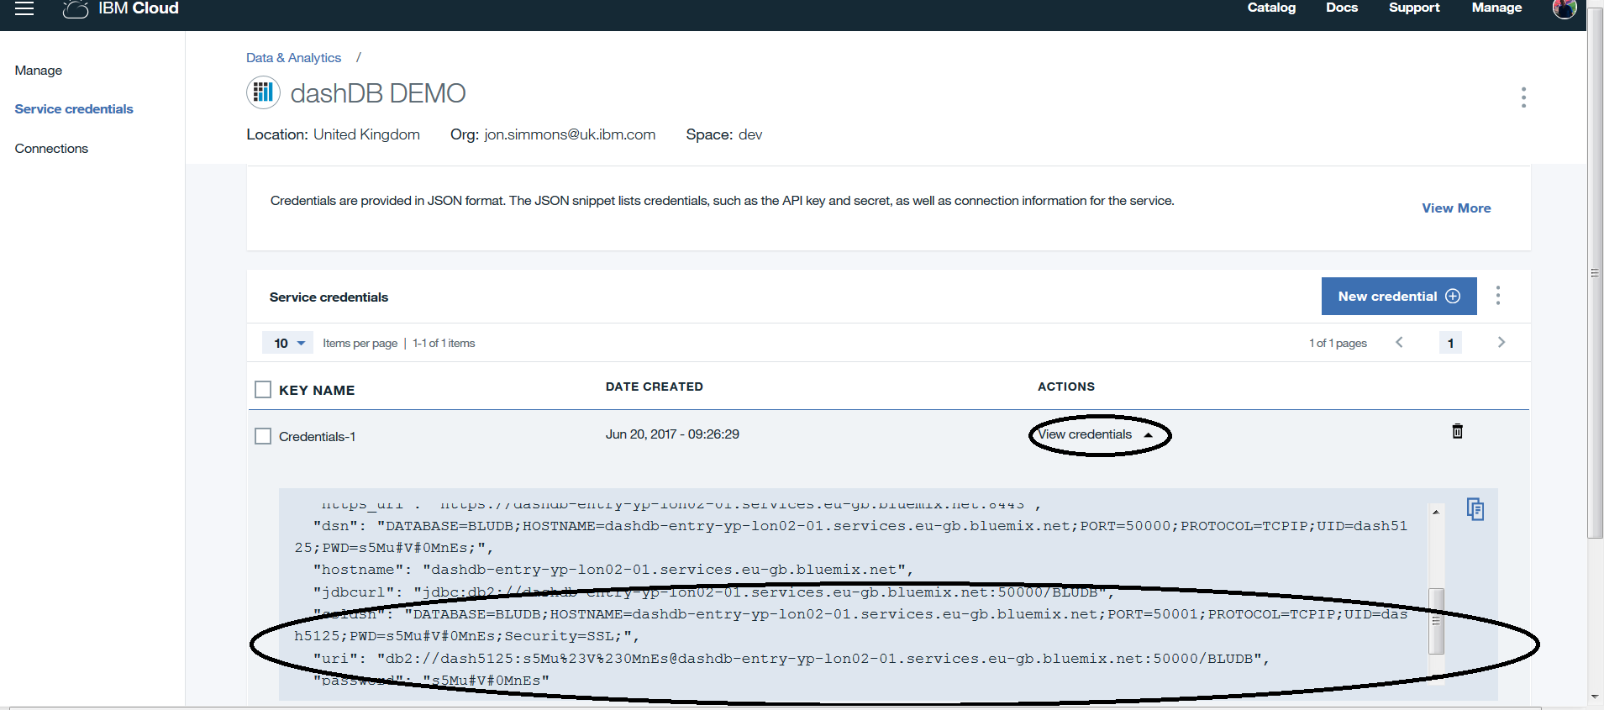

The credentials can be found by pressing the View Credential drop down (Circled) and the details are shown in the lines circled.

From this credential screen we can see that the following are the credentials for the database: -

HOST NAME IP ADDRESS: dashdb-entry-yp-lon02-01.services.eu-gb.bluemix.net

DATABASE: BLUDB

USERNAME: dash5125

PASSWORD: s5Mu#V#0MnEs

Click the create button once the properties are filled in and you can now work with your connection in Watson Analytics.

The data is now ready to be discovered in Watson Analytics.

**Discover**

From the main screen click on the Db2 warehouse on cloud connection or the XLSX data sets. The following discovery screen will be displayed. Suggestion interesting questions and correlations.

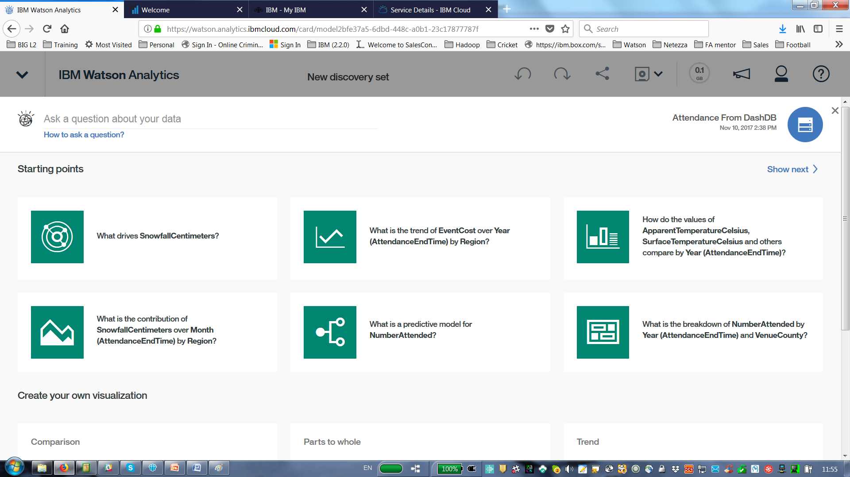

There is a saved discovery set called No Attended V1 if you select the discovery set tab. This saved discovery set contains 8 tabs of interesting information. The key thing is to determine NoAttended and the factors which affect that including the weather data.

8 Tabs Include:-

1. Decision Tree

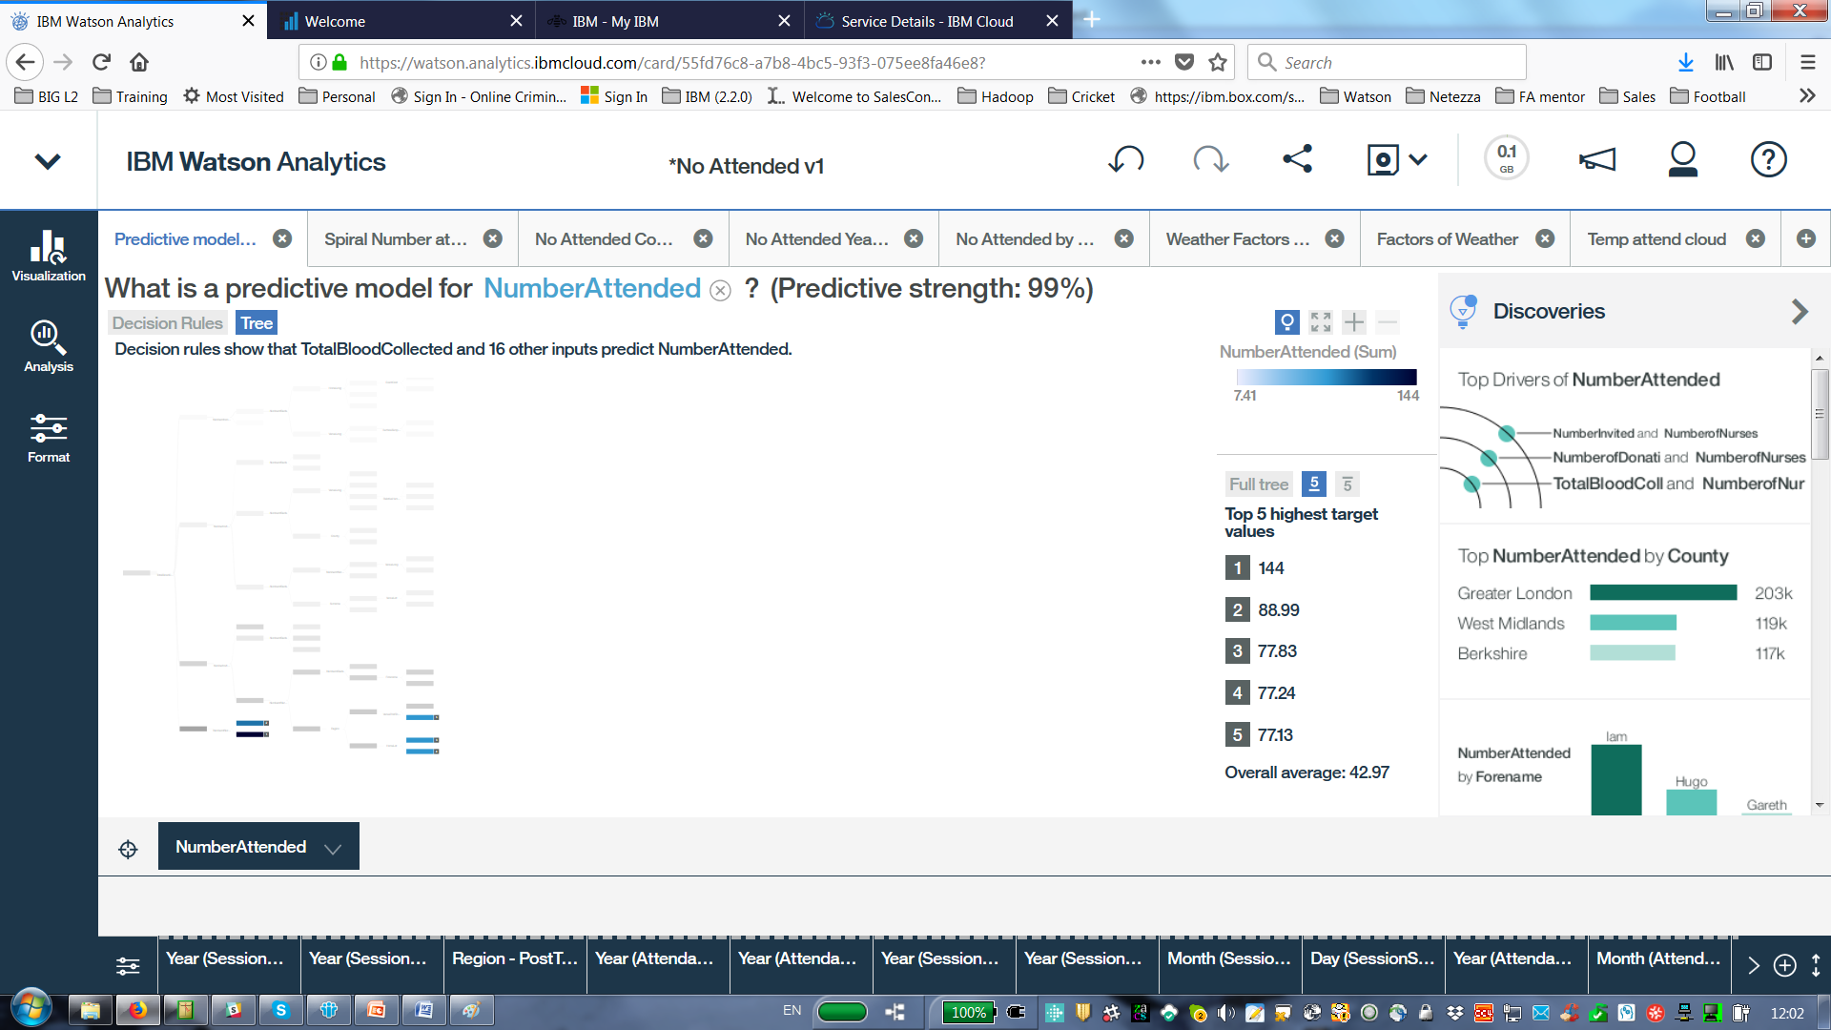

1. Spiral of Number Attended

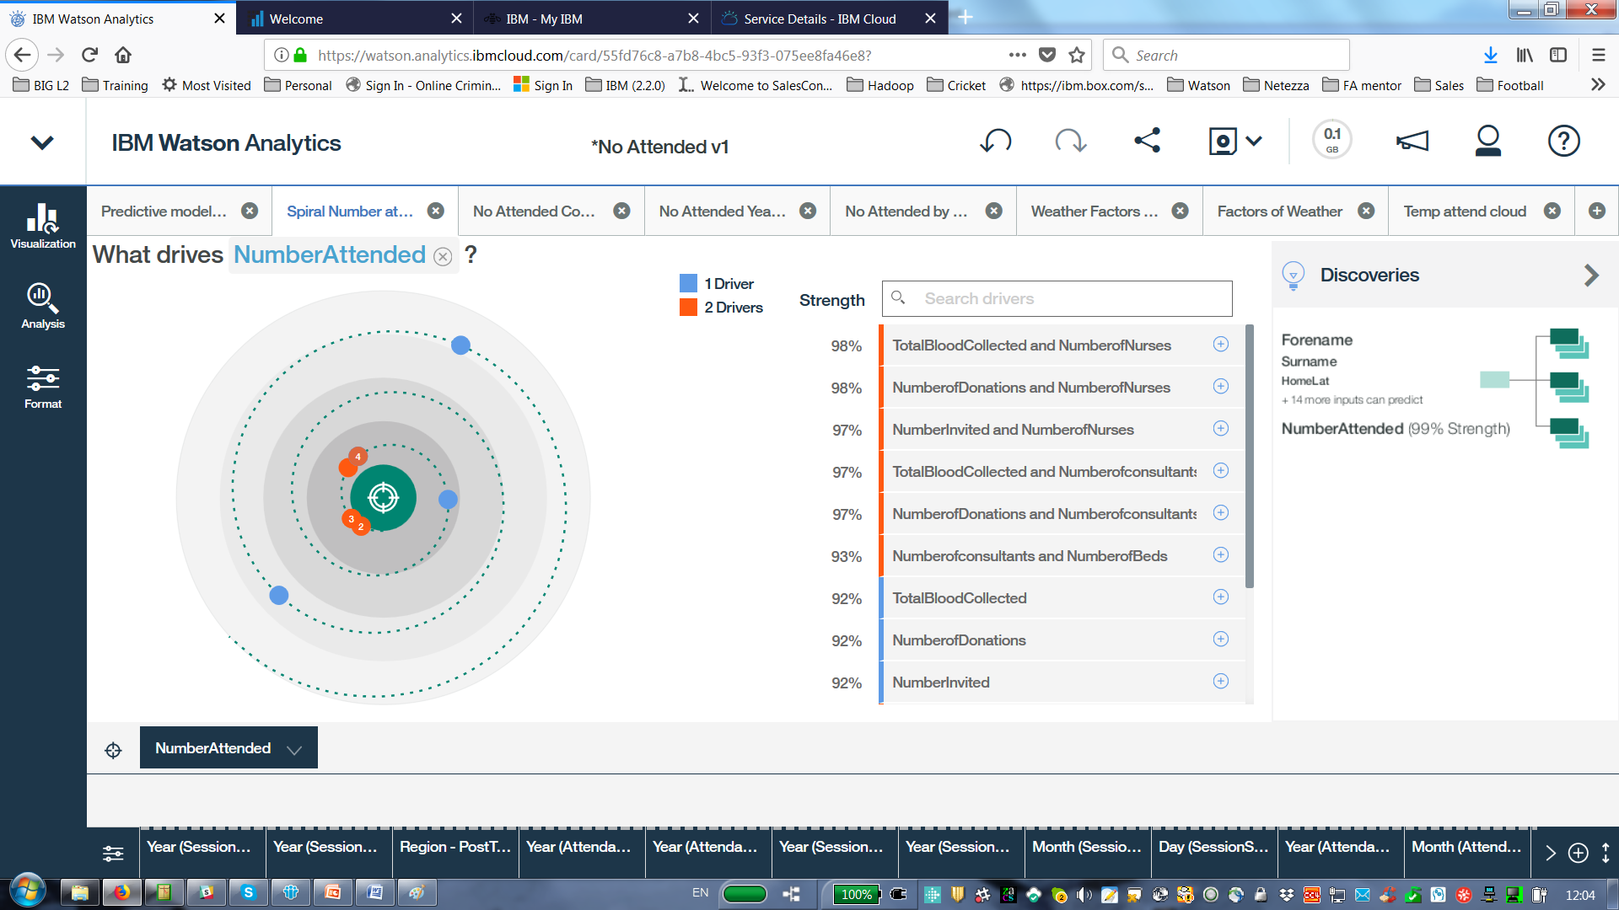

1. Number Attended related to County and apparent temperature

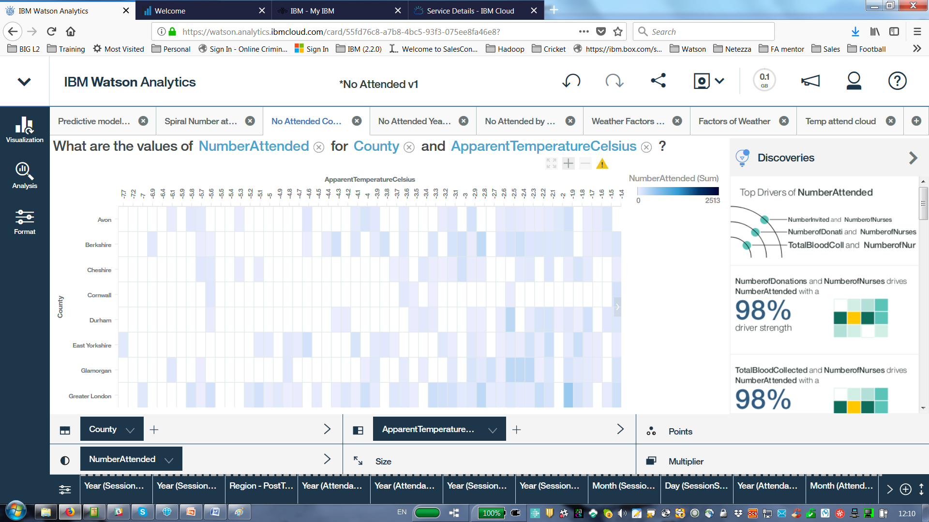

1. Number attended by Year and Venue County

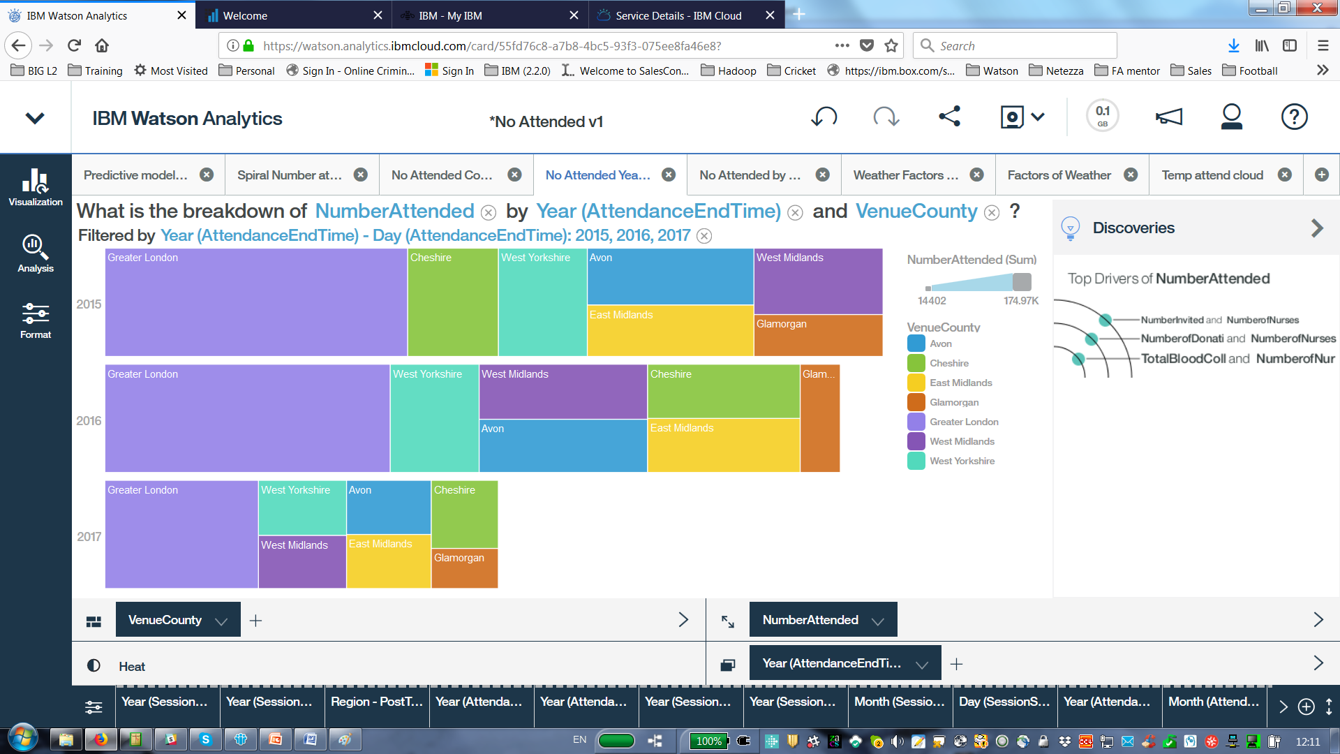

1. Number attended by Cloud Coverage (Either 100, 99 or ) percent the most popular)

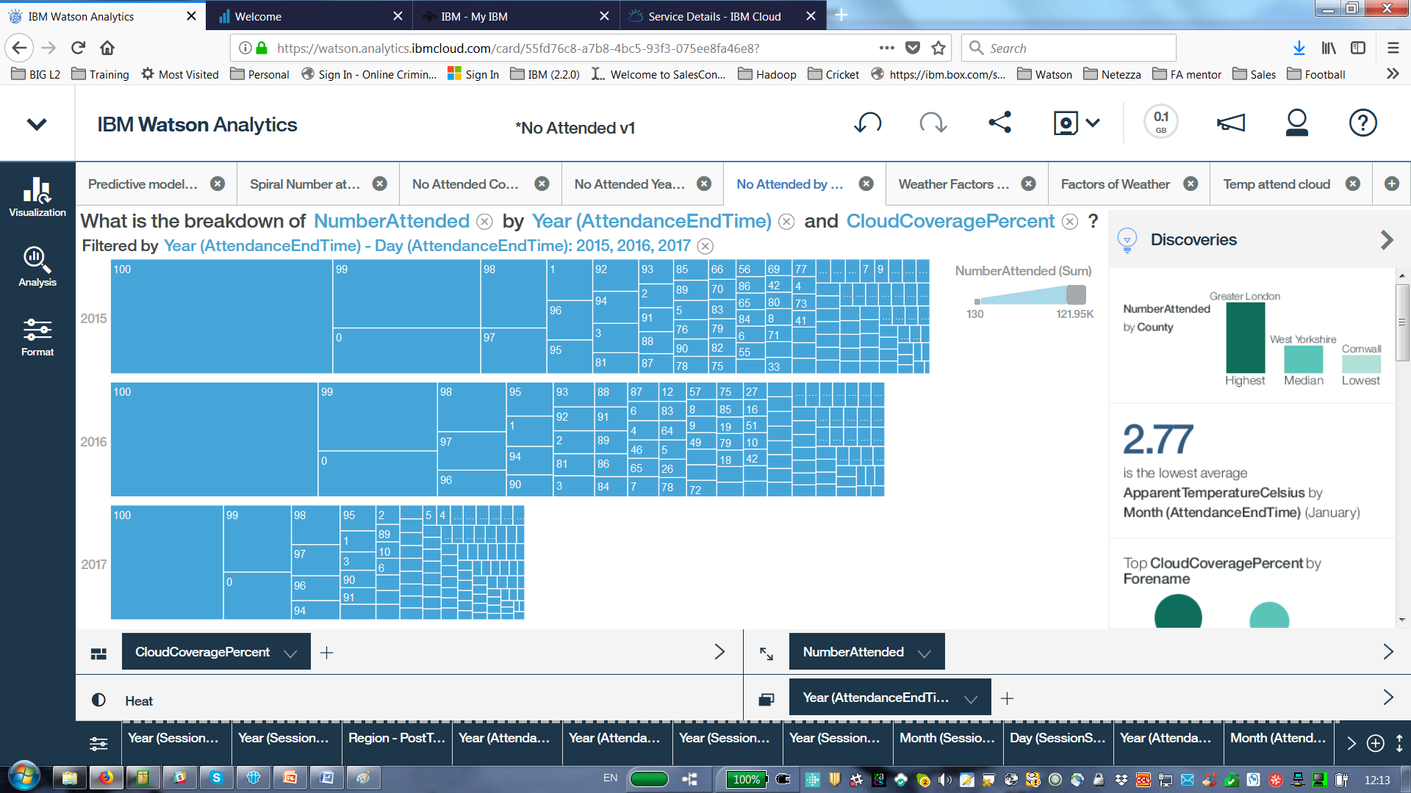

1. Weather Factors affecting attendance

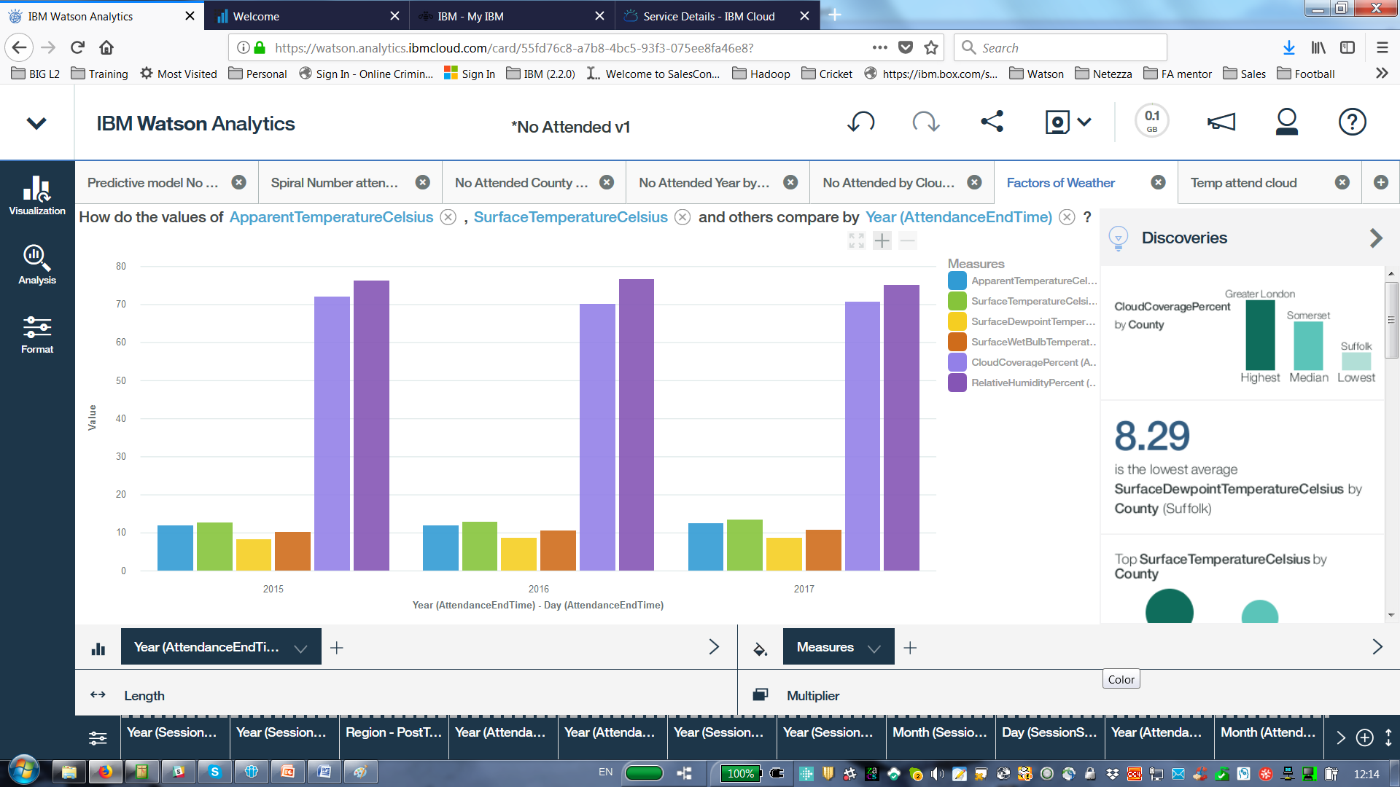

1. Number attended, Apparent temperature Cloud Coverage

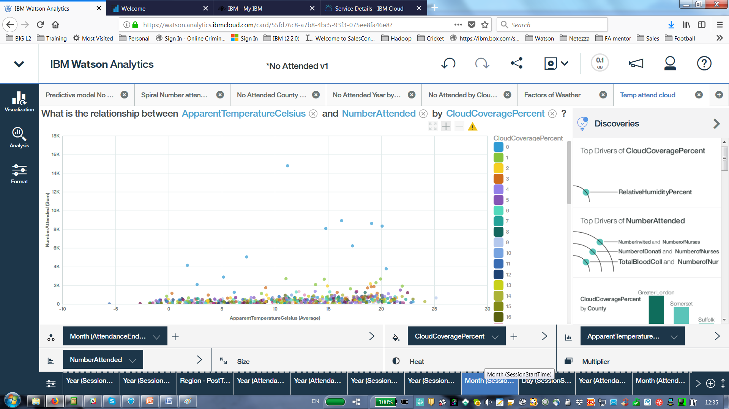

**Display**

Four of the abovetabs have been added to a display, which allows interaction between the parameters on each tab. See below.

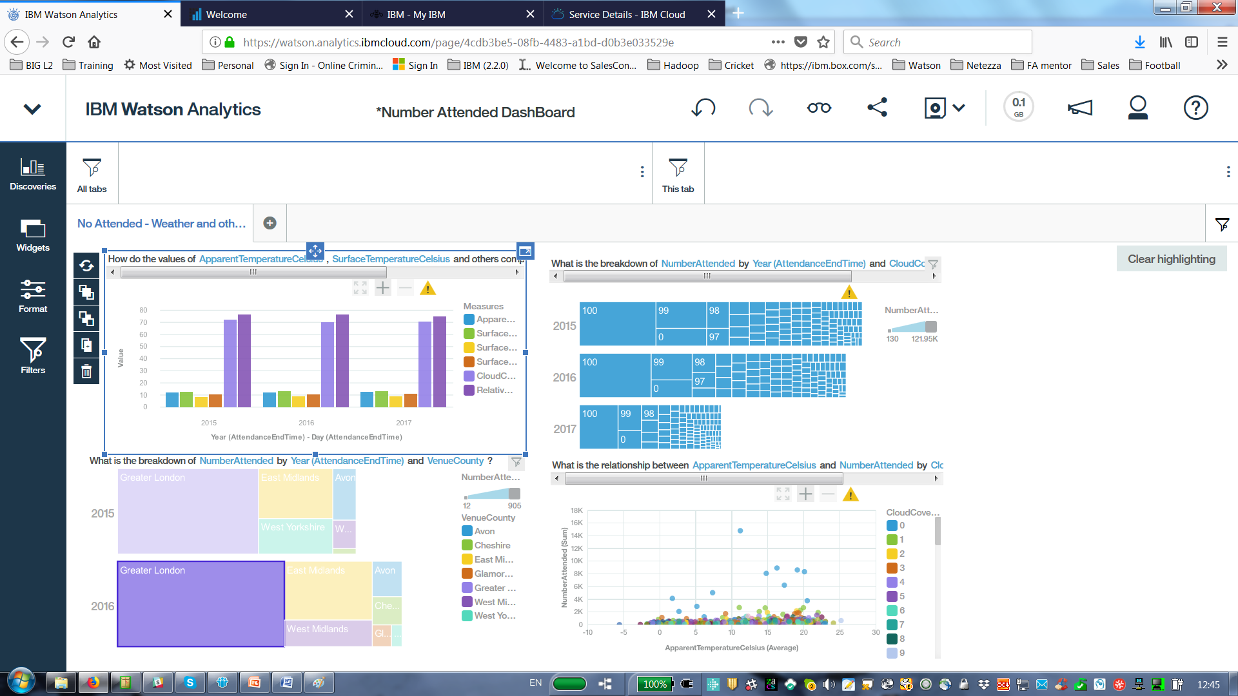

# DSX Demo on the data

The following diagram shows the Attendance Demonstration in DSX.

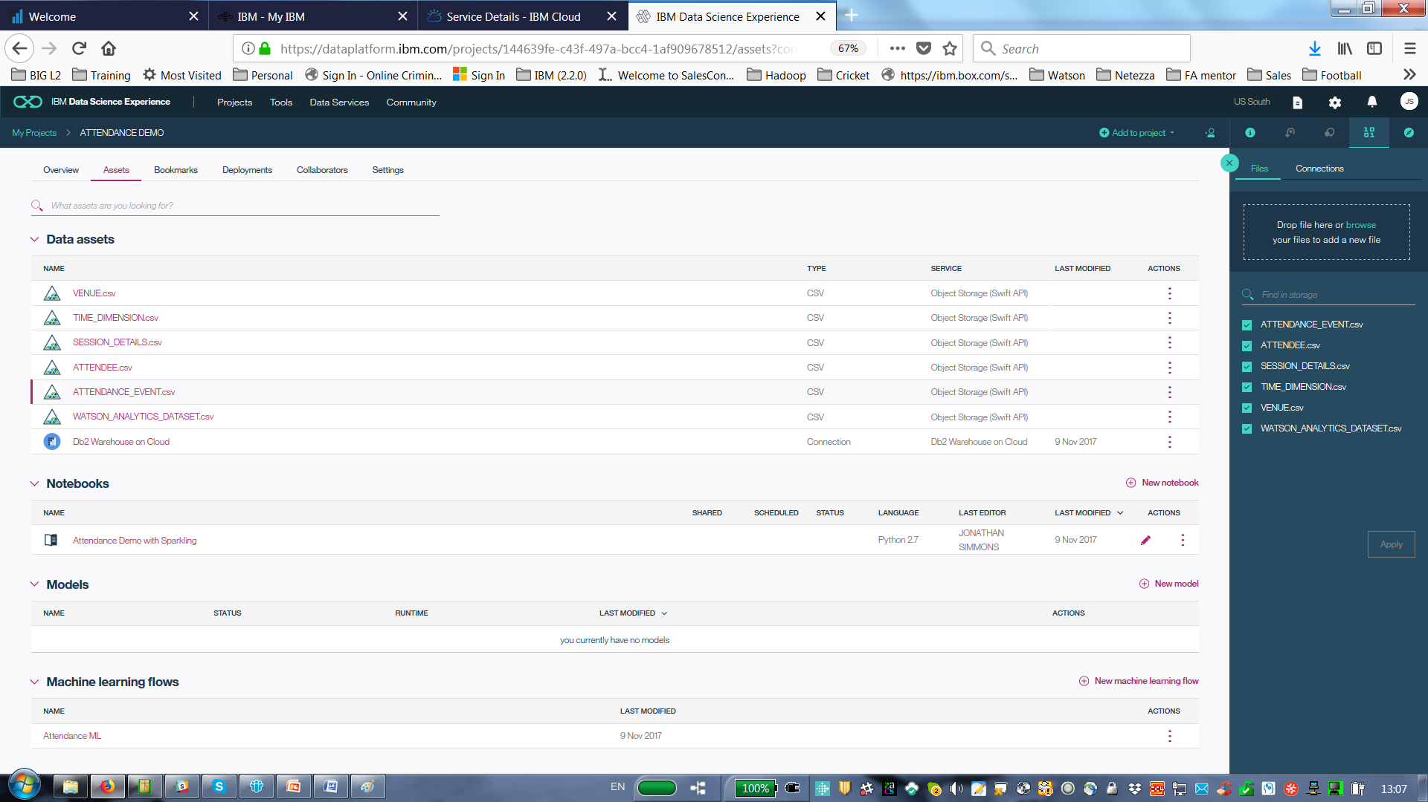

The data assets have been added to the project, a notebook has been created to display weather data and machine learning using SPSS modeler have been created.

# Jupyter Notebook Demo on the Attendance Data with Weather

The Jupyter Notebook written in Python does the following:

* Uses a cut down version of the Watson Analytics data set
* Displays attendance against various weather aspects
* Plots the weather data on a UK map.

# Machine Learning – SPSS Modeler Demo on the Attendance Data

The following diagram shows the Attendance Demonstration in DSX. It is created in SPSS Modeler Canvas in DSX. By click on the Attendance ML in the machine models part of the main project screen will bring up the model below.

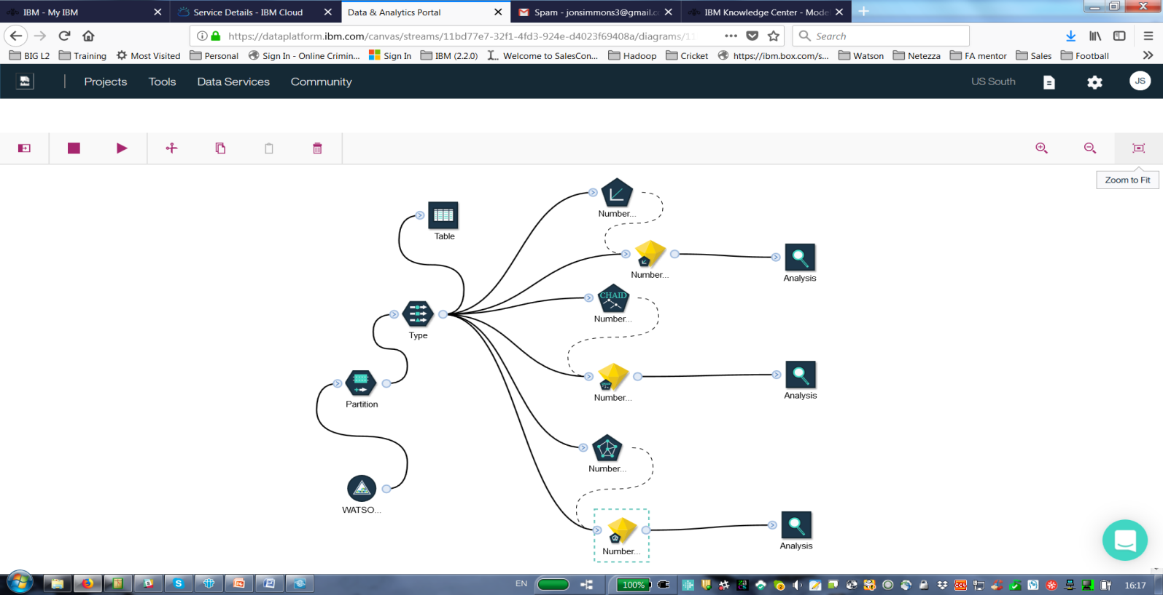

The data set created in Db2 Warehouse on Cloud and used in the Watson analytics demo is used here as the source node (data Asset in DSX). It is connected to a partition node which uses some of the data to train the model and then the rest of the data to test the machine learning model. The data is passed through a type node to select the inputs and the target. Various models (Linear Regression, Chaid 5.0 and a Neural network) are then run to create deployable models shown by the nuggets. These models can be reviewed and analysed. A table node is used to show the output of the raw data.

## Example run of the Neural network

BY click on the Neural network node and selecting the 3 dot menu you have the option to run the model as shown below: -

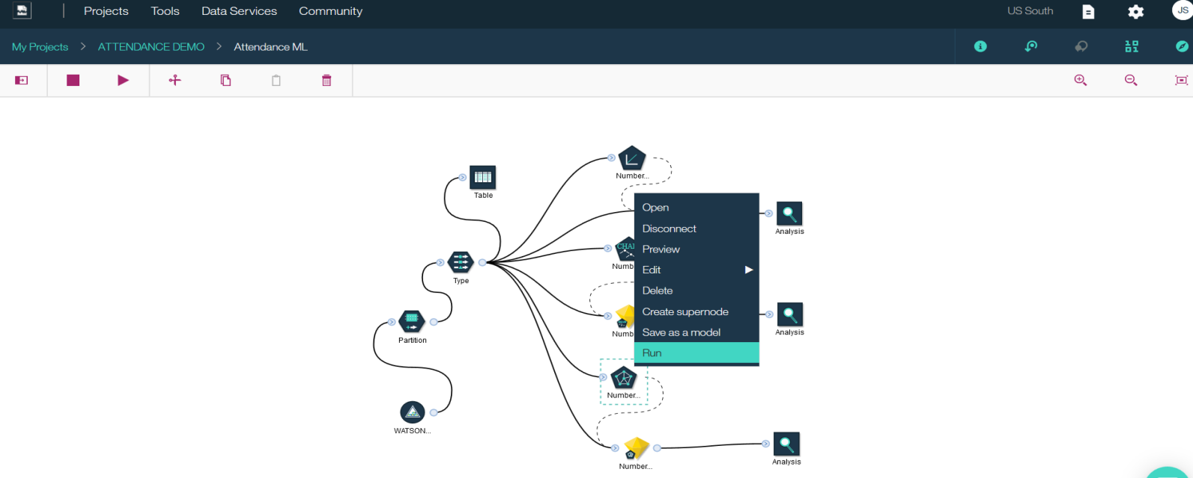

Once you click run the following message will appear and the nugget will be updated with the latest run.

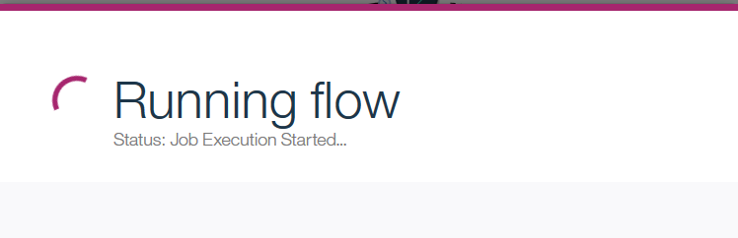

Now click on the Nugget for the Neural Network and the dot menu and select View Model as shown below: -

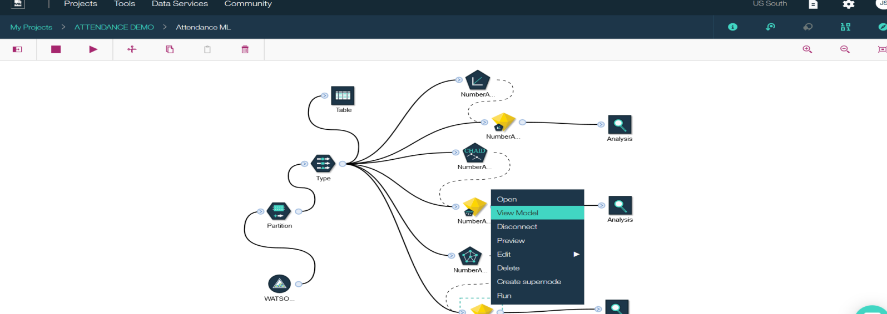

A model evaluation screen is displayed as shown below (This model is not very predictive): -

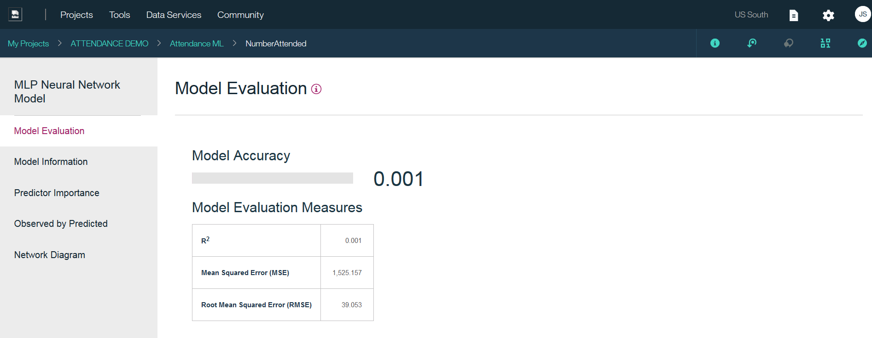

Select the Predictor Importance to view the weight of prediction of certain weather factors on the number attending. as shown below: -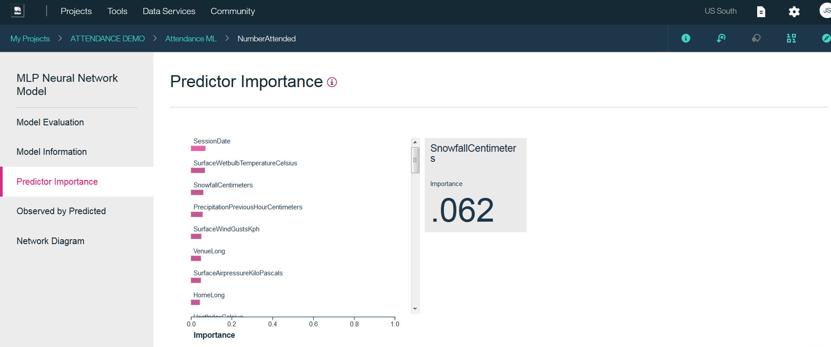

These nuggets can be saved into the models section DSX and can be deployed in Watson machine Learning against various platforms from that models section of the Analytic assets of DSX.

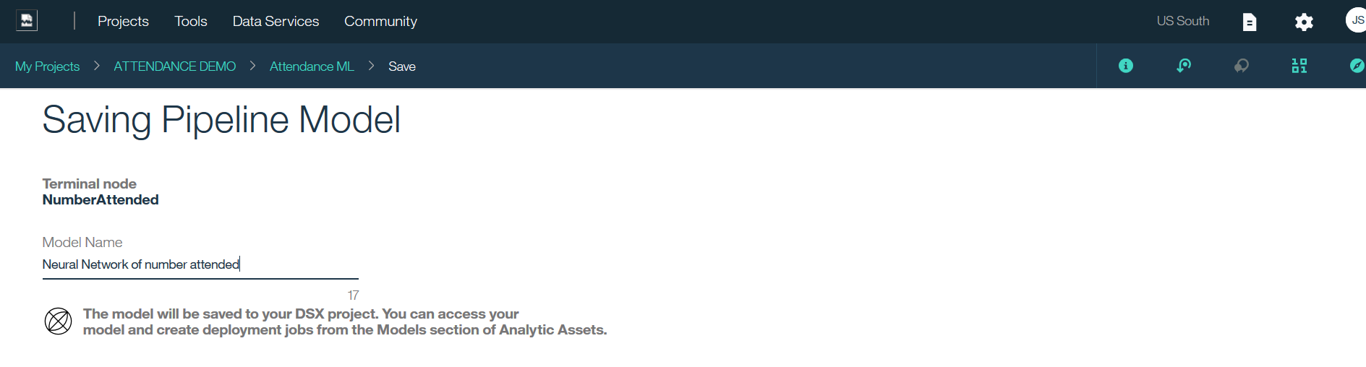

In the models section you can also create a model from scratch. You need to make sure you have a predictor model run time (machine Learning instance service and a Spark Service) running.